**Android Medical Application**

Kohinoor Haque ID : 161-15-6807

Email:kohinoor15-6807@diu.edu.bd

Department of CSE

**Abstract:** The technological revolution has impacted industries across the world, providing businesses with the opportunity to develop custom solutions for their particular needs. The medical field is no exception in this respect. Although this field often deals with complex or sensitive data, doctors and patients can greatly benefit from taking advantage of the ever-growing mobile platform through the development of various medical mobile apps. Medical Assistance application has rich features that allow the patients or people to monitor their health own a personal level. To build a medical mobile app that has successful impact, the patient's best interests should be a top priority.

**Keywords**: DISEASES, CONTACT, ABOUT DOCTOR ,EXIT.

**Introduction**

Medical application are application programs that offer health-related services for smartphones and laptops. My project ‘Android Medical App’ which is developed by using Android Studio and programming language is java. The patients are the ones who receive the most benefits of the Medical apps whether it is scheduling a quick appointment with the doctor, finding an appropriate specialist with hands on experience, viewing the medical test reports from labs online, purchase medicines and other products at affordable prices and see various kinds of diseases and its syndrome. This app specially helps patients to connect with doctors . The apps help to update the doctors about the health condition of their patients.

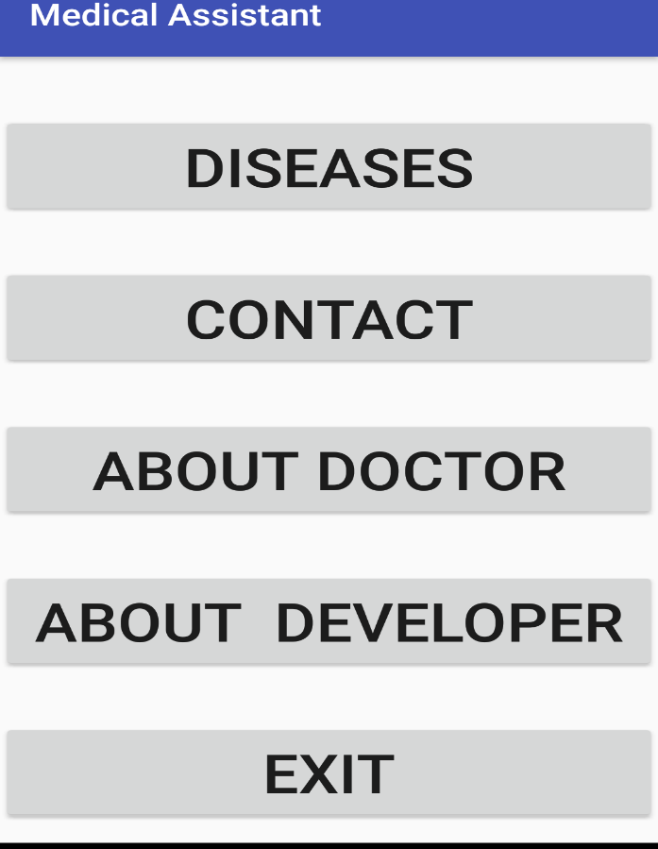

Figure:01

**DISEASES**

A disease is a particular abnormal condition that negatively affects the structure or function of part or all of an organism, and that is not due to any external injury. Every disease has a particular syndrome. In this features patient want to know about diseases and its syndrome and also diseases basic cause. Patient find out easily which is their problem or which diseases syndrome is match. To prevent diseases firstly need to know the cause of diseases. This feature is use for this and also it helps the both of patient and doctors. If someone wants to know about diseases it also can helps both doctor and patient.

**CONTACT**

Doctor-patient communication is a central clinical function in building a doctor-patient relationship, which is the heart and art of medicine. To connect with doctor need some way. There are two way to connect with doctor one is online and this is Email and another is offline and this is SMS. When email use for

Communication patient also need email address. Another way is SMS, for this need valid phone number. Ability to collect and analyze patient health information from Medical application.

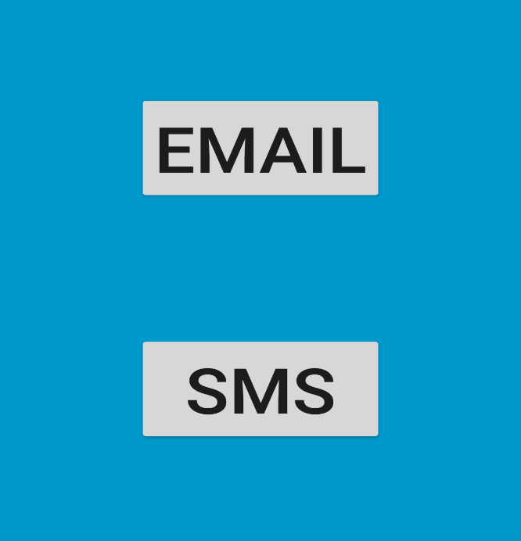

**Figure:02**

**ABOUT DOCTOR**

A medical doctor is a person who uses medicine to treat illness and injuries. So many kinds of doctors for various kinds of diseases. Depend on department doctors categories are selected .Such as Medicine Doctor, Cardiologists, surgery etc. In this features contain doctors name, which kind of doctor and basic information of doctors. If patient need medicine doctors they can easily find which doctors are available and choose one of them.

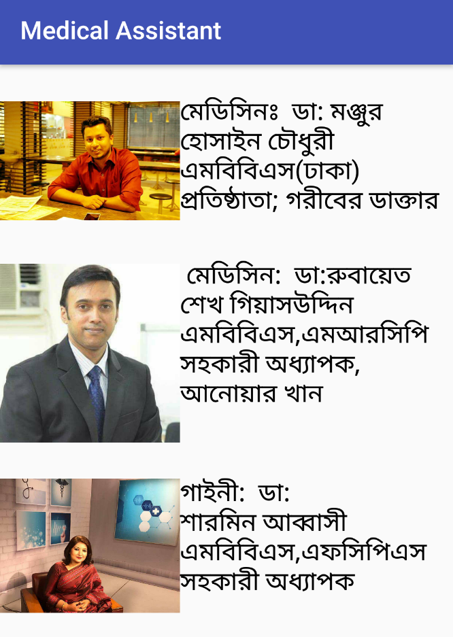

**Figure:03**

**EXIT**

When you collect your information and you do not need this application than you can go out from this site easily press exit option .

**Conclusion**

Android Medical apps are a part of the movement towards mobile health (mHealth) programs in health care. This application allows smartphone and tablet, laptop users to send and receive messages within an organization at low of cost. This communication does not need to interact with mobile service provider or no need to take any big data plan. So this way it reduces the cost of communication between doctor and patient. To build a medical assistance mobile app that has successful impact, the patient's best interests should be a top priority.